Revising the Select Query II
Easy
Basic Select
Query the NAME field for all American cities in the CITY table with populations larger than 120000. The CountryCode for America is USA.
The CITY table is described as follows:
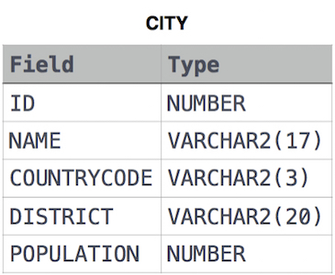
Query:-
SELECT NAME
FROM CITY
WHERE COUNTRYCODE='USA'
AND POPULATION>120000;

Congratulations!
You have passed the sample test cases. Click the submit button to run your code against all the test cases.
Sample Test case 0

Your Output (stdout)
- Scottsdale
- Corona
- Concord
- Cedar Rapids

Expected Output
- Scottsdale
- Corona
- Concord
- Cedar Rapids

